**Ryan A Peguero**

**CS-330**

**Cozy Living Room**

This proposal outlines a plan to replicate a 2D scene of a cozy living room in 3D using OpenGL and C++. The scene includes a sofa, coffee table, floor lamp, bookshelf, and a carpeted floor.

Picture Sample:

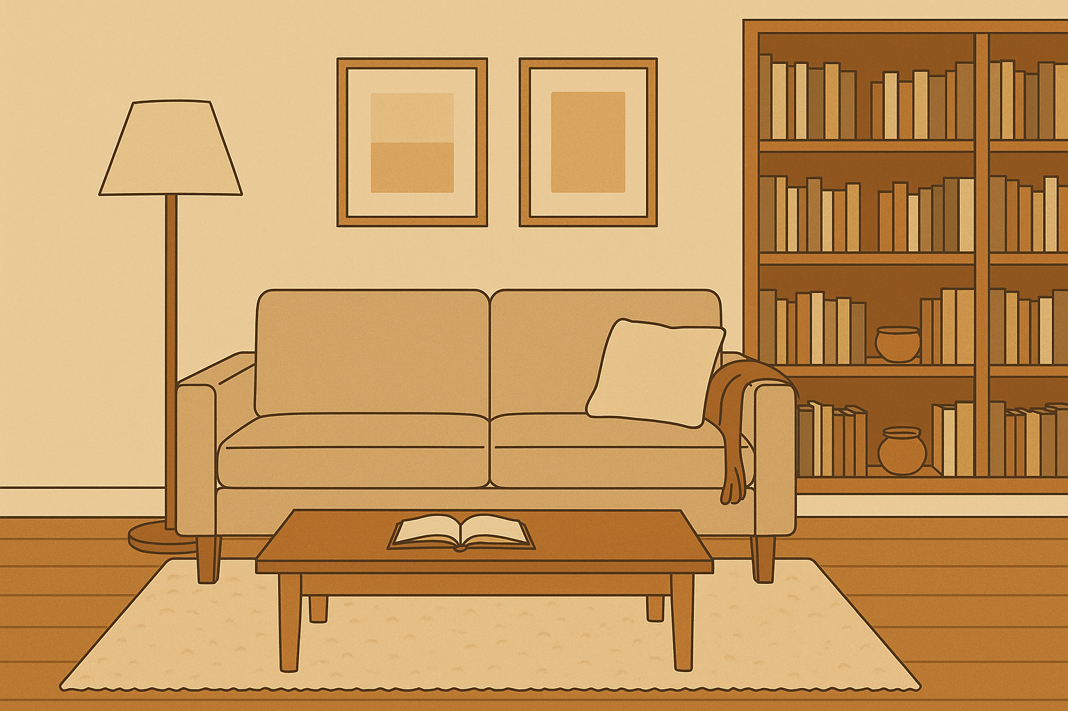

**2D Image Selection**

* **Front View**: An image showcasing a sofa, coffee table, floor lamp, and bookshelf arranged around a carpet.
* **Side View**: An additional angle highlighting the proportions of the lamp and bookshelf.

**Rationale**:

* **Clarity**: The objects have distinct geometric forms, simplifying their translation to 3D.
* **Multiple Angles**: Side and front views aid in accurately scaling objects and understanding spatial relationships.
* **Complexity**: The scene includes organic and rigid shapes, offering diverse options.

### **3D Objects to Replicate**

Four key objects will be modeled, along with a floor plane to ground the scene:

**Sofa**

A two-seater sofa with cushioned seats and wooden legs. It combines multiple shapes (boxes for cushions, cylinders for legs).

**Coffee Table**

A rectangular wooden table. Simple structure, box + cylinders.

**Floor Lamp**

A modern lamp with a cylindrical base and conical shade. Distinct shapes (cylinder + cone) allow exploration of lighting effects later.

**Bookshelf**

A tall wooden shelf with five compartments. It is built from stacked boxes, demonstrating alignment and repetition.

**Floor (Plane)**

A textured carpet beneath the furniture. This provides a foundational plane for grounding objects.

### **Basic 3D Shapes for Each Object**

Each object is deconstructed into basic 3D shapes to ensure achievable modeling:

|  |  |
| --- | --- |
| **Object** | **Component Shapes** |
| **Sofa** | - 2 Boxes (seat/backrest)  - 4 Cylinders (legs) |
| **Coffee Table** | - 1 Box (wooden top)  - 4 Cylinders (legs) |
| **Floor Lamp** | - 1 Cylinder (base)  - 1 Cone (shade) |
| **Bookshelf** | - 5 Boxes (shelves/sides) |
| **Floor** | - 1 Plane (carpet) |

**Total Unique Shapes Used**: Box, Cylinder, Cone, Plane.

**Achievability**

All objects use foundational shapes, which helps with compatibility with OpenGL’s built-in primitives. The lamp’s conical shade will later integrate emissive materials for realistic glow. I believe that the coffee tabletop can look like glass, but this is something I am going to play with later on.

**Challenges and Solutions**:

Use glScalef() to adjust object sizes relative to the floor plane. Leverage glTranslatef() to position stacked bookshelf boxes accurately. The sofa’s curved armrests may require combining multiple boxes, but this proposal focuses on simplified geometry for feasibility.